INTERNAL IT ASSET MANAGEMENT SYSTEM
A PROJECT REPORT
Submitted by
RAJESHGANESH S
(2116241501161)
in partial fulfilment of the End Semester Examination for the course

CB23F35 –
LOW-CODE APPLICATION DEVELOPMENT USING ZOHO CREATOR
in
BACHELOR OF TECHNOLOGY
Artificial Intelligence and Machine Learning



RAJALAKSHMI ENGINEERING COLLEGE
(An Autonomous Institution, Affiliated to Anna University, Chennai)
Rajalakshmi Nagar, Thandalam, Tamil Nadu – 602 105
2026-2027

RAJALAKSHMI ENGINEERING COLLEGE
(An Autonomous Institution, Affiliated to Anna University, Chennai)
BONAFIDE CERTIFICATE
Certified that this project report titled “INTERNAL IT ASSET MANAGEMENT SYSTEM” is the bonafide work of RAJESHGANESH S (2116241501161), who carried out the individual project work on the Zoho Creator low-code platform for the course CB23F35 – Low-Code Application Development using Zoho Creator, during the academic year 2026–2027, Semester V, under my supervision.
SIGNATURE  Dr Ayyadurai M  HEAD OF THE DEPARTMENT  Department of Artificial Intelligence  And Machine Learning  Rajalakshmi Engineering College  Thandalam – 602 105 | SIGNATURE  Ms Priya M  COURSE FACULTY  Assistant Professor  Department of Artificial Intelligence  And Machine Learning  Rajalakshmi Engineering College

Submitted for the End Semester Examination (Individual Project) held on Not evidenced.
INTERNAL EXAMINER | EXTERNAL EXAMINER

DECLARATION
I, RajeshGanesh S (2116241501161), declare that this project report titled “INTERNAL IT ASSET MANAGEMENT SYSTEM,” submitted for the End Semester Examination of CB23F35 – Low-Code Application Development using Zoho Creator, records the individual project work completed by me. The application configuration and implementation described here are based on the supplied Zoho Creator application export and screenshots. Any external references used are cited in the report.
I further declare that this work has not been submitted, in part or in full, for the award of any other degree or course credit.

Place: Chennai SIGNATURE OF THE STUDENT
Date: 21 October 2026 Not evidenced
2116241501161

ACKNOWLEDGEMENT
I express my sincere gratitude to our Chairman, Mr Meganathan M, Chairperson, Ms Thangam Meganathan and Vice-Chairman, Mr Abhay Meganathan for providing the infrastructure and facilities that made this work possible.
I am grateful to our Principal, Dr Murugesan SN, Rajalakshmi Engineering College, for the constant encouragement extended to students to take up industry-relevant learning.
I thank, Dr Ayyadurai M, Head of the Department, Department of Artificial Intelligence and Machine Learning for the guidance and support provided throughout the course.
I sincerely thank my course faculty, Ms Priya M, Assistant Professor, for her guidance, reviews and feedback during the development of this application and report.
I also acknowledge Zoho Corporation / Zoho Creator Education Programme for providing access to the Zoho Creator platform and learning resources, and I thank my family and friends for their unwavering support.

RajeshGanesh S

ABSTRACT
Organizations depend on laptops, monitors, printers and other technology assets to support daily work. When asset records, employee assignments, support requests and maintenance activities are tracked across separate spreadsheets and messages, staff may not have a consistent view of who holds an asset, whether it is available, or what work remains open. This project models an internal IT department that needs a shared record of its assets, employees, requests, assignments and maintenance work.
The Internal IT Asset Management System was built in Zoho Creator. Its five data-entry forms cover Asset, Asset Assignment, Employee, IT Request and Maintenance Record. Eight reports provide register views and grouped views for request status, asset category, employee department and maintenance type. A dashboard summarizes purchase costs, request counts, asset assignments, priorities and asset costs by status and category. The project export also defines a form workflow that emails an employee’s manager when an assignment is returned, a warranty reminder schedule, and process stages for IT requests and asset maintenance.
The supplied export and screenshots demonstrate the application structure, populated records, dashboard, reports, workflow, schedule and maintenance lifecycle blueprint. They do not establish measured performance, formal user acceptance testing, production deployment, external integrations, or configured application permission profiles. Those items are identified as unverified or future work rather than reported as completed results.
Keywords: Low-Code Development; Zoho Creator; IT Asset Management; Deluge; Workflow Automation; Asset Lifecycle

PROJECT AT A GLANCE

Attribute | Details
Project Title | Internal IT Asset Management System
Application Domain | Internal Information Technology Operations
Student Name & Register No. | RajeshGanesh S – 2116241501161
Zoho Creator Edition | Not identified in supplied export
Application Name (Link Name) | Internal IT Asset Management System (Internal_IT_Asset_Management_System)
Published / Live URL | URL not recorded in report materials
Demo Credentials (per role) | Not included; use assigned Creator accounts
Number of Forms / Subforms | 5 forms / no subforms evidenced
Number of Reports (by type) | 8 register and grouped reports
Number of Pages / Dashboards | 1 dashboard page evidenced
Number of Workflows | 1 form workflow; 1 schedule; Blueprint stages
Deluge Functions / Custom Actions | Return notification and warranty reminder; no standalone function evidenced
Integrations | No external integration evidenced; built-in sendmail actions present
Roles & Profiles Defined | Employee role values include Administrator, Employee, Manager, IT Staff; permissions not verified
Environments Used | Not documented
Date of Production Deployment | Not documented

TABLE OF CONTENTS
Formatting Standards (Anna University Convention) 1
Working with the Template 1
ABSTRACT iv
PROJECT AT A GLANCE v
LIST OF TABLES ix
LIST OF FIGURES x
LIST OF ABBREVIATIONS xi
INTRODUCTION 1
1.1 Background 1
1.2 Problem Statement 1
1.3 Objectives 1
1.4 Scope of the Project 1
1.5 Justification for a Low-Code Approach 2
1.6 Organisation of the Report 2
LITERATURE SURVEY AND SYSTEM STUDY 3
2.1 Study of the Existing System 3
2.2 Limitations of the Existing System 3
2.3 Low-Code versus Traditional Development 3
2.4 Literature Survey 4
2.5 Emerging Trends in Low-Code Development 4
2.6 Proposed System 4
REQUIREMENT ANALYSIS 5
3.1 Stakeholders and User Roles 5
3.2 Functional Requirements 5
3.3 Non-Functional Requirements 5
3.4 Hardware and Software Requirements 6
3.5 Use Case Model 6
SYSTEM DESIGN 8
4.1 System Architecture 8
4.2 Data Model 8
4.3 Form Design 9
4.4 Process and Workflow Design 9
4.5 User Interface and Navigation Design 10
4.6 Access Control Design 10
IMPLEMENTATION 11
5.1 Application Setup 11
5.2 Forms and Data Capture 11
5.3 Reports 12
5.4 Pages and Dashboards 13
5.5 Deluge Scripting 13
5.6 Workflows and Automation 14
5.7 Integrations 15
5.8 User Management and Role-Based Access 16
5.9 AI and Analytics Features 16
5.10 Pro-Code Extension 17
5.11 Mobile and Portal Access 17
TESTING AND DEBUGGING 18
6.1 Testing Strategy 18
6.2 Test Cases 18
6.3 Debugging Deluge Scripts 18
6.4 Defect Log 19
6.5 User Acceptance Testing 19
DEPLOYMENT, SECURITY AND GOVERNANCE 20
7.1 Environments and Deployment Strategy 20
7.2 Performance Optimisation 20
7.3 Security Features 21
7.4 Governance and Administration 21
RESULTS AND DISCUSSION 22
8.1 Application Output 22
8.2 Achievement of Objectives 23
8.3 Comparison with the Existing System 23
8.4 Limitations of the Low-Code Approach 23
8.5 Reflection on the No-Code → Low-Code → Pro-Code Spectrum 23
CONCLUSION AND FUTURE ENHANCEMENTS 24
9.1 Conclusion 24
9.2 Future Enhancements 24
9.3 Learning Outcomes and Career Relevance 24
REFERENCES 25
APPENDIX A – ZOHO CREATOR FEATURE COVERAGE CHECKLIST 26
APPENDIX B – COURSE OUTCOME MAPPING 28
APPENDIX C – COMPLETE DELUGE SOURCE CODE 29
APPENDIX D – USER MANUAL 30
D.1 Accessing the Application 30
D.2 Instructions for IT Staff 30
D.3 Instructions for Employees and Managers 30
APPENDIX E – EVALUATION RUBRIC 31
APPENDIX F – VIVA-VOCE RECORD SHEET 33

LIST OF TABLES
Table 2.1: Comparison of Low-Code and Traditional Development for the Proposed Application 3
Table 2.2: Summary of Literature Survey 4
Table 3.1: Stakeholders and User Roles 5
Table 3.2: Functional Requirements 5
Table 3.3: Non-Functional Requirements 5
Table 3.4: Hardware and Software Requirements 6
Table 3.5: Use Case Description – Not evidenced 6
Table 4.1: Entities and Relationships 9
Table 4.2: Field Specification – Not evidenced Form 9
Table 4.3: Role–Permission Matrix 10
Table 5.1: Reports Implemented 12
Table 5.2: Deluge Scripts Implemented 13
Table 5.3: Workflows Implemented 14
Table 5.4: Integrations Implemented 15
Table 6.1: Test Cases 18
Table 6.2: Defect Log 19
Table 6.3: User Acceptance Feedback 19
Table 7.1: Deployment Checklist 20
Table 7.2: Performance Optimisation Results 20
Table 7.3: Security Controls Implemented 21
Table 8.1: Mapping of Objectives to Outcomes 23
Table 8.2: Existing System versus Proposed Application 23
Table A.1: Feature Coverage Checklist 26
Table B.1: Mapping of Course Outcomes to Report Chapters 28
Table E.1: Evaluation Rubric for the Individual Project 31
Table E.2: Performance Level Descriptors 32
Table F.1: Viva-Voce Questions and Responses 33
Table F.2: Marks Summary 33

LIST OF FIGURES
Figure 2.1: Manual IT Asset and Request Process Used as the Baseline 3
Figure 3.1: User Roles and Main Application Use Cases 6
Figure 4.1: Zoho Creator Application Architecture 8
Figure 4.2: Core Entity Relationships in the Application 8
Figure 4.3: Asset Return Notification and Warranty Reminder Processes 10
Figure 4.4: Application Navigation and Dashboard 10
Figure 5.1: Application Dashboard and Navigation 11
Figure 5.2: IT Request Form 11
Figure 5.3: Asset Assignment and Asset Forms 12
Figure 5.4: Request and Assignment Reports 12
Figure 5.5: Dashboard Summary and Asset Category View 13
Figure 5.6: Request Status, Workflow and Warranty Schedule 15
Figure 5.7: No External Integration Configuration Supplied 16
Figure 5.8: Employee Role Form and Department Report 16
Figure 5.9: Dashboard Charts and Cost Summaries 17
Figure 5.10: Employee Directory; Mobile and Portal Access Not Verified 17
Figure 6.1: Request Status Board; No Debug Log Supplied 19
Figure 7.1: Live Dashboard; Environment History Not Supplied 20
Figure 7.2: Audit Trail Not Verified; Blueprint Shown in Figure 5.6 21
Figure 8.1: Dashboard with Sample Asset and Request Metrics 22
Figure 8.2: Asset Assignment and Inventory Reports 22
Figure 8.3: Maintenance Records and Lifecycle Views 22

LIST OF ABBREVIATIONS
This list defines abbreviations used in this report.
Abbreviation | Expansion
API | Application Programming Interface
CRUD | Create, Read, Update, Delete
ER | Entity–Relationship
IT | Information Technology
JSON | JavaScript Object Notation
LCAP | Low-Code Application Platform
RBAC | Role-Based Access Control
REST | Representational State Transfer
UAT | User Acceptance Testing
UI | User Interface
Zoho Creator | Low-code application platform

CHAPTER 1

INTRODUCTION

1.1 Background
Introduce the domain and the organisation (real or realistic) for which the application is built. Explain how the process works today and who is involved. 1–2 pages.
The project addresses internal IT asset administration in a sample organization with employees at a head office, branch office and remote location. The application maintains records for five sample assets, five employees, five assignments, four IT requests and five maintenance entries, as shown in the supplied application screenshots. These records illustrate the data flow and are demonstration data rather than a claim about a real organization. The main users represented in the employee data are administrators, IT staff, managers and employees. The process begins when IT staff register equipment and employees, then record an allocation, service request or maintenance activity. Reports and the dashboard provide a shared view of the resulting records.

1.2 Problem Statement
State the problem precisely in one paragraph, followed by 3–5 specific pain points (e.g., data duplication across spreadsheets, delayed approvals, no real-time visibility, manual reporting, no access control).
The project addresses fragmented IT asset information and service activity. Without a common record system, asset ownership, request progress, maintenance history and warranty dates can be difficult to review together. The application brings these records into related Zoho Creator forms and presents them through reports and a dashboard.
- Asset, employee, assignment, request and maintenance details are stored in separate form records and must be related consistently.
- Request and maintenance progress is represented through status fields and process stages, so users need to consult the corresponding report or board to understand current state.
- Warranty reminders and returned-asset notifications depend on correctly entered dates, employee links and manager contact information.

The objectives below describe the functions implemented or evidenced in the supplied application.
- To create structured forms for assets, employees, assignments, IT requests and maintenance records.
- To organize asset request and maintenance progression with statuses, a form workflow, a schedule and Blueprint stages.
- To provide register reports, grouped reports and a dashboard for inventory, request, assignment and maintenance monitoring.
- To relate records using employee and asset lookups and document the project’s email automation; no external service integration is evidenced in the supplied export.
- To document testing, access control and deployment requirements and distinguish verified configuration from work that remains unverified.

1.4 Scope of the Project
In scope are the five forms, their related lookups, eight reports, one dashboard page, an asset-return manager notification workflow, a warranty reminder schedule, request status stages and the Asset Maintenance Lifecycle blueprint. The screenshots show a web application interface. Mobile-specific behavior, customer portal access, production release, enterprise role permissions and third-party integrations are outside the verified evidence for this report.
Not evidenced

1.5 Justification for a Low-Code Approach
Zoho Creator suits this prototype because its visual form and report builders support the linked records and status views required by the project, while Deluge can extend event-driven behavior for email notifications. A blueprint provides a visual way to represent ordered process stages. This combination lets the project demonstrate data capture, reporting and workflow automation without building a separate web stack. The platform’s managed hosting and mobile capabilities are platform features; the supplied evidence does not establish that mobile access or production governance was configured in this application [1], [2].
Not evidenced

1.6 Organisation of the Report
Chapter 2 studies the manual baseline, low-code development and related sources. Chapter 3 records project requirements. Chapter 4 presents the data model, processes and access design. Chapter 5 describes the Zoho Creator implementation. Chapter 6 defines the verification evidence and test plan. Chapter 7 documents deployment, security and governance status. Chapter 8 reviews the demonstrated outputs and limitations. Chapter 9 concludes the report and lists future enhancements.
CHAPTER 2

LITERATURE SURVEY AND SYSTEM STUDY

2.1 Study of the Existing System
The baseline used for comparison is a typical manual process for a small internal IT team; no separate legacy application or measured baseline was supplied. An employee reports a fault or requests equipment by email or message. IT staff identify the requester and equipment, enter or update a spreadsheet, coordinate approval, arrange allocation or repair, and later update the record. Managers request status summaries, which staff prepare by filtering or combining files. This process description is a project assumption used for analysis, not an audited description of a named organization.
Employee reports a need → IT staff review details and locate the asset record → manager approval is sought when applicable → IT assigns equipment or schedules work → staff update status and notes → reports are compiled for review. Each handoff can depend on a person updating a separate record.

Employee reports need → IT staff review and locate asset → manager review if applicable → equipment allocation or maintenance → status update → report/dashboard review.
Figure 2.1: Manual IT Asset and Request Process Used as the Baseline

2.2 Limitations of the Existing System
- Asset, employee and service records may be duplicated or become inconsistent across separate files.
- Status tracking and approvals depend on manual follow-up, which can make outstanding work less visible.
- Combining data for inventory, cost, warranty and maintenance summaries requires repeated manual reporting.

2.3 Low-Code versus Traditional Development
For this project, Zoho Creator low-code development provides reusable form, lookup, report and workflow configuration in one application. A traditional application would require separate implementation of its database, user interface, hosting, authentication and deployment pipeline. The low-code route reduces the amount of infrastructure code but still requires careful data modeling, Deluge scripting, permission review and platform-specific configuration. No comparative development-time measurement was recorded; therefore the comparison is qualitative.
Table 2.1: Comparison of Low-Code and Traditional Development for the Proposed Application
Criterion | Traditional (Pro-Code) Development | Low-Code on Zoho Creator
Development time | Separate implementation of data, UI, hosting and workflows; no estimate measured. | Visual form, report and workflow configuration reduces custom infrastructure code; no estimate measured.
Skills required | Programming, database, web and deployment skills. | Creator configuration, data modeling and Deluge skills.
Hosting & infrastructure | Selected and maintained by development team. | Provided as part of Creator; app-specific setup still required.
Mobile application | Requires responsive UI or separate client work. | Creator offers mobile access; this project tested web screens only.
Security & access control | Implemented through selected identity and authorization components. | Platform supports permissions; project permission profiles not verified.
Maintenance & change | Changes require code, build and deployment practices. | Forms and reports can be changed visually; Deluge and platform dependencies remain.
Customisation limits | Broad control over architecture and UI. | Faster configuration within platform capabilities and limits.
Cost | Depends on engineering, hosting and maintenance choices. | Depends on subscription and configuration effort; actual project cost not recorded.

2.4 Literature Survey
The survey below uses two peer-reviewed review papers and three primary Zoho Creator documentation sources. The literature supports a balanced assessment: low-code can accelerate delivery, while complexity, governance and platform constraints remain design considerations [1], [2]. Zoho’s documentation describes Creator workflows and blueprints as configurable mechanisms for event handling and staged processes [3]–[5].
Table 2.2: Summary of Literature Survey
S.No. | Author(s) / Source & Year | Title / Product | Key Findings | Relevance to this Project
1 | Gao et al., 2026 | Systematic review of low-code viability | Reports development-speed benefits with context-dependent quality and complexity outcomes. | Supports balanced evaluation; does not prove this project’s performance.
2 | da Silva et al., 2024 | Review of low-code/no-code adoption | Reviews adoption drivers and challenges, including governance and platform dependence. | Frames platform lock-in and governance considerations.
3 | Zoho Corporation, 2026 | Zoho Creator Quickstart Guide | Shows an IT asset use case with forms, lookups, approvals, Blueprints and reports. | Directly relevant platform documentation.
4 | Zoho Corporation, 2026 | Understanding workflows | Describes workflow types and event-driven automation in Creator. | Supports terminology for form workflow and schedule.
5 | Zoho Corporation, 2026 | Creating blueprints | Explains stages, transitions and actions in a Blueprint. | Supports the maintenance lifecycle design.

2.5 Emerging Trends in Low-Code Development
Relevant trends include citizen development through visual builders, automation across record lifecycles, and AI-assisted application design. This project uses visual forms, reports and a dashboard together with Deluge and workflow configuration, which places it in the low-code category. No AI-generated feature or external analytics service is evidenced in the supplied export; AI and advanced analytics are therefore treated as possible extensions rather than implemented capabilities.

2.6 Proposed System

The proposed application centralizes the five record types and presents them in related reports. The IT Request form records request type, requester, related asset, subject, description, priority, dates, status, assigned IT staff and resolution notes. The Asset Assignment form records the employee, asset, dates, status, issuer and notes. Maintenance records link to an asset and can reference a request. Dashboard metrics and grouped reports reduce the need to manually combine separate lists. A return notification and warranty reminder add targeted email automation, while Blueprint stages represent maintenance and request progress.
CHAPTER 3

REQUIREMENT ANALYSIS

3.1 Stakeholders and User Roles
Table 3.1: Stakeholders and User Roles
Role | Description | Key Responsibilities in the Application
Administrator | Employee role value; app permissions not verified. | Maintain records and coordinate configuration; validate access before operational use.
Manager | Employee role value. | Review requests and assignment returns; manager notification configured for returns.
IT Staff | Employee role value. | Register assets, manage assignments, record requests and maintenance updates.
Employee | Employee role value. | Submit or be recorded as requester; permissions not verified.

3.2 Functional Requirements
The requirements are expressed as observable application behavior. Test execution results are not inferred from the presence of a configured form or workflow.
Table 3.2: Functional Requirements
FR ID | Requirement | Role(s) | Priority
FR-01 | Store asset identity, category, purchase cost, warranty date, status and location. | IT Staff, Administrator | High
FR-02 | Store employee identity, department, contact details and organizational role. | Administrator, IT Staff | High
FR-03 | Record an assignment with linked asset and employee, dates, status and issuer. | IT Staff | High
FR-04 | Record an IT request with requester, asset, description, priority, status and resolution details. | Employee, IT Staff | High
FR-05 | Record maintenance type, linked asset, technician, status, cost and dates. | IT Staff | High
FR-06 | Provide register and grouped reports for requests, assignments, assets, employees and maintenance. | IT Staff, Manager, Administrator | Medium
FR-07 | Present dashboard metrics and charts for asset costs, requests, priorities and assignments. | Manager, IT Staff, Administrator | Medium

3.3 Non-Functional Requirements
Table 3.3: Non-Functional Requirements
NFR ID | Category | Requirement
NFR-01 | Performance | Measure report and dashboard performance with representative data; no threshold recorded.
NFR-02 | Security | Restrict access using verified Creator permissions before real employee data is used.
NFR-03 | Usability | Use clear field labels and navigation; screenshots evidence a web interface.
NFR-04 | Availability | Availability depends on Creator service and account; no project-specific target recorded.
NFR-05 | Maintainability | Use consistent form, field and workflow names and document Deluge changes.
NFR-06 | Auditability | Enable and review available record history or audit features before production; configuration not verified.

The project is implemented as a Zoho Creator application and accessed through a modern web browser. Deluge is the scripting language used by Creator. The screenshots show a web interface; no specific browser version, device specification, API testing tool, or mobile client test was recorded.
Table 3.4: Hardware and Software Requirements
Category | Specification
Platform | Zoho Creator; edition not identified
Scripting language | Deluge
Browser | Web browser; exact browser/version not recorded
API testing tool | Not applicable; no API call supplied
Other Zoho services | No external service connection evidenced
Mobile | Not verified
Client hardware | Internet-connected computer capable of running a supported browser; minimum not measured

3.5 Use Case Model
The use case model summarizes the four user categories represented in employee records. The available evidence shows a role field on the Employee form, but does not verify that separate Creator permission profiles were configured.

Actors: Administrator, Manager, IT Staff, Employee. Use cases: maintain employees/assets; record assignment/return; submit/track request; record maintenance; review reports/dashboard.
Figure 3.1: User Roles and Main Application Use Cases
Table 3.5: Use Case Description – Not evidenced
Use Case ID | UC-01
Use Case Name | Submit and track an IT request
Actor(s) | Employee or IT Staff
Pre-condition | User can access Creator; permissions to be verified.
Main Flow | 1. Open IT Request. 2. Enter requester, related asset, subject, description and priority. 3. Submit. 4. Review in IT Request Report / Statuses.
Alternate Flow | If required information is missing, correct the form before submission. Validation was not independently tested.
Post-condition | An IT Request record is available in application reports.
Related FR | FR-04, FR-06
CHAPTER 4

SYSTEM DESIGN

4.1 System Architecture
The application is presented through the Zoho Creator web interface. Users navigate to forms to add or update records, reports to review records, grouped views to inspect status or category, and a dashboard for summary metrics. Form data is stored in the Creator application and linked through lookups to asset, employee and request records. The exported configuration defines Deluge email actions, a schedule and Blueprint stages. No external API, CRM or analytics connection is evidenced.

Users → Zoho Creator web interface → five forms → Creator records and lookups → reports/dashboard; workflow and Deluge actions run within Creator.
Figure 4.1: Zoho Creator Application Architecture
The system has three logical layers: (1) users access the application through the Creator web interface; (2) the application layer contains five forms, eight reports, a dashboard, workflows and Blueprint configurations; and (3) the Creator data layer stores form records and their lookup relationships. Deluge scripts and workflow actions operate within the application layer. The available export does not show a separate external integration layer.

4.2 Data Model
Relate to Unit II – Data Modelling. Present the ER diagram, then explain each entity and its relationships. In Zoho Creator, relationships are realised through lookup fields (one-to-many / many-to-many) and subforms (parent–child).

Employee 1—* Asset Assignment *—1 Asset; Employee 1—* IT Request; Asset 1—* IT Request; Asset 1—* Maintenance Record; IT Request 0..1—* Maintenance Record.
Figure 4.2: Core Entity Relationships in the Application
Table 4.1: Entities and Relationships
Entity (Form) | Key Fields | Related To | Relationship Type | Implemented Using
Asset | Asset Id, tag, name, category, cost, warranty end, status | Assignment, Request, Maintenance | One asset to multiple records | Asset lookup/list fields
Employee | Employee Id, name, department, email, role, manager | Assignment, IT Request | Employee linked to assignments and requests | Employee lookup/list fields
Asset Assignment | Assignment Id, asset, employee, dates, status | Asset, Employee | Many assignments may reference asset or employee | Asset and Employee list fields

4.3 Form Design
The project contains five forms. Asset records capture identification, category, manufacturer, model, serial number, purchase and warranty dates, cost, assignees, location and notes. Employee records capture identity, department, contact, role, active status, location, manager and department code. Asset Assignment records link assets and employees, with assignment and return details. IT Request records link requester and related asset and track priority, status, assigned staff and resolution. Maintenance Record links an asset and optionally an IT request, and records type, description, technician, status, cost and dates. The following table gives representative field specifications; the complete field set is in the supplied Creator export.
Table 4.2: Field Specification – Not evidenced Form
Field Label | Link Name | Field Type | Mandatory | Validation / Default | Remarks
Asset Id | asset_id | Single Line / text | Not specified | No validation evidenced | Asset record identifier
Category | category | Drop Down / picklist | Not specified | Laptop, Monitor, Accessory, Desktop, Printer, Mobile; other allowed | Asset classification
Purchase Cost | purchase_cost | Currency (USD) | Not specified | No default evidenced | Shown in cost reports
Warranty End Date | warranty_end_date | Date | Not specified | Date field; used by schedule | Reminder criteria in export
Status | status | Drop Down / picklist | Not specified | Assigned, Retired, Available, Under Maintenance | Asset state

The exported form definitions provide the field names and types summarized in Table 4.2. The screenshots in Chapter 5 show the live forms and reports.

4.4 Process and Workflow Design
Draw a flowchart or swim-lane diagram for each automated process (e.g., request → validation → approval → notification → status update). Mark where Deluge scripts and workflows run.

Returned assignment → On Success workflow → fetch employee/manager/asset → email manager if address exists. Warranty within 30 days → schedule → gather assigned employee emails → send reminder.
Figure 4.3: Asset Return Notification and Warranty Reminder Processes

4.5 User Interface and Navigation Design
Show the navigation structure (sections/menus) and wireframes of key pages and dashboards before implementation.

Dashboard; IT Request (form/report/statuses); Asset Assignments (form/report); Assets (form/all assets/categories); Employees (form/all employees/departments); Maintenance Records (form/all records/types).
Figure 4.4: Application Navigation and Dashboard

4.6 Access Control Design
The employee form includes an organizational role value (Administrator, Employee, Manager or IT Staff). This records a business role, but it is not evidence of Creator permission-profile or record-level access configuration. The matrix below is a proposed access design for a future role-permission review; permissions must be verified in Creator before being treated as implemented.
Table 4.3: Role–Permission Matrix
Component | Administrator | Manager | IT Staff | Employee
Asset and Employee forms | Proposed: A E V D | Proposed: V | Proposed: A E V | Proposed: V
Assignment and Request forms | Proposed: A E V D | Proposed: V | Proposed: A E V | Proposed: A V (own)
Maintenance forms and reports | Proposed: A E V D | Proposed: V | Proposed: A E V | Proposed: —
Dashboard and grouped reports | Proposed: V | Proposed: V | Proposed: V | Proposed: —
Status | Not verified in supplied evidence | Not verified | Not verified | Not verified
CHAPTER 5

IMPLEMENTATION
This chapter reports the configuration visible in the supplied .ds export and screenshots. Where the material does not demonstrate a feature, the report identifies that limit instead of assuming it was configured.

5.1 Application Setup
The application is named Internal IT Asset Management System and uses the link name Internal_IT_Asset_Management_System. The export defines five forms and groups application navigation into Dashboard, IT Request, Asset Assignments, Assets, Employees and Maintenance Records. The supplied screenshots show the live interface and sample records. The exact creation method and environment promotion history are not present in the export.
Not evidenced

Dashboard Overview
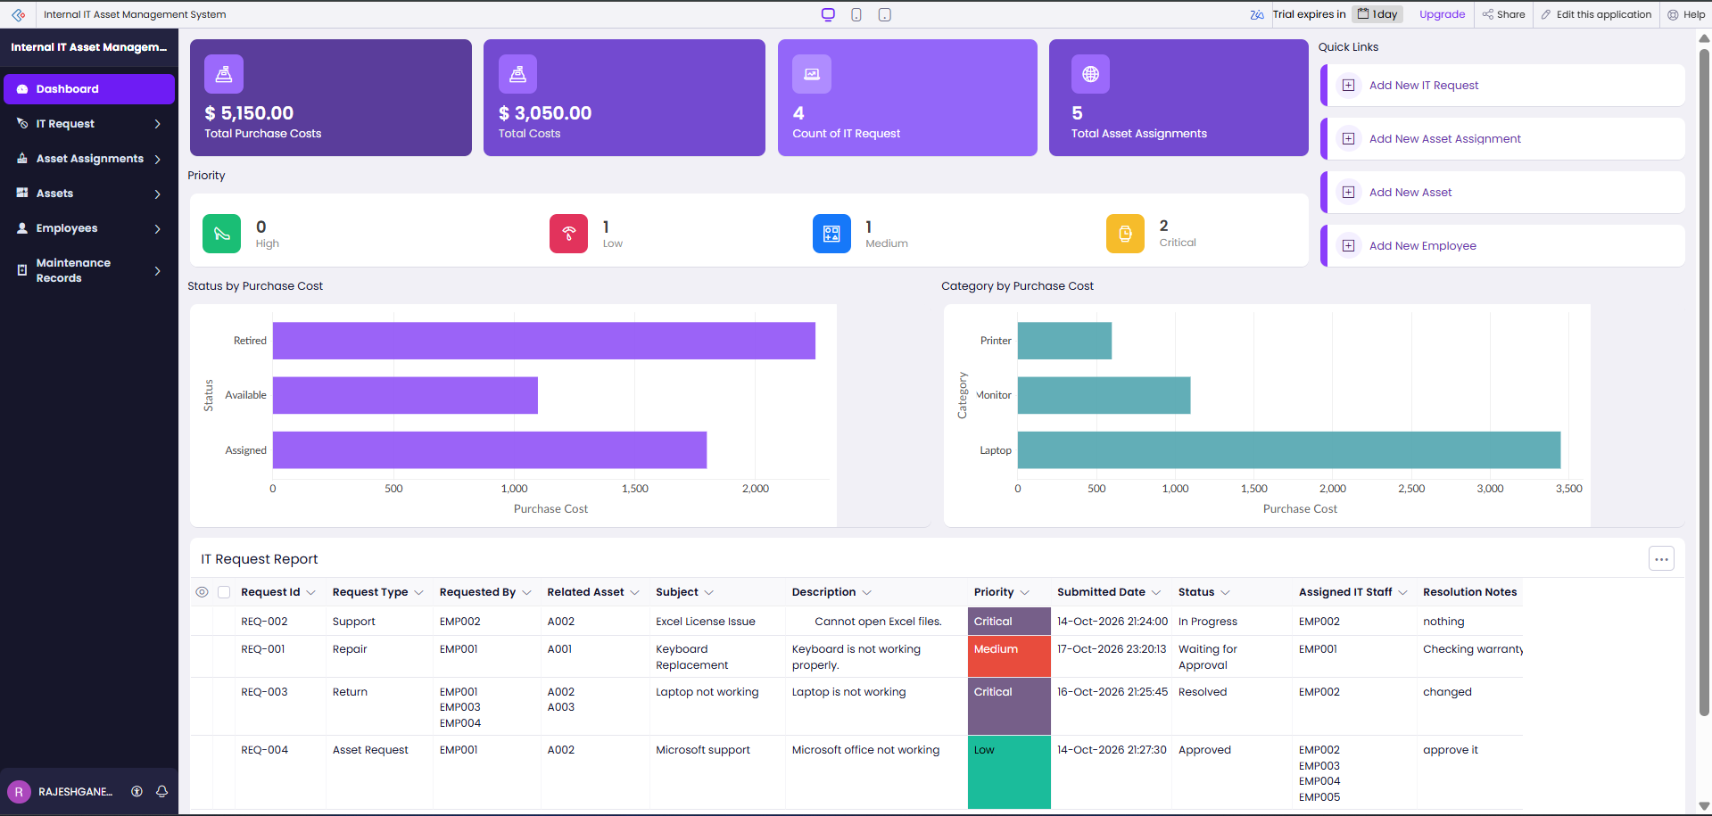
Figure 5.1: Application Dashboard and Navigation

5.2 Forms and Data Capture
The five forms capture the core data. Asset and Employee are master records. Asset Assignment links an asset to one or more employees and stores assignment status and dates. IT Request links the requester and related asset and captures issue details, priority and resolution. Maintenance Record links an asset and request and records maintenance type, technician, status, cost and completion. The exported .ds file defines text, picklist, date, currency, list/lookup, name, email, checkbox, phone, date-time and textarea fields. The screenshots show the visible form layouts and sample register data.
Not evidenced

Create an IT Request
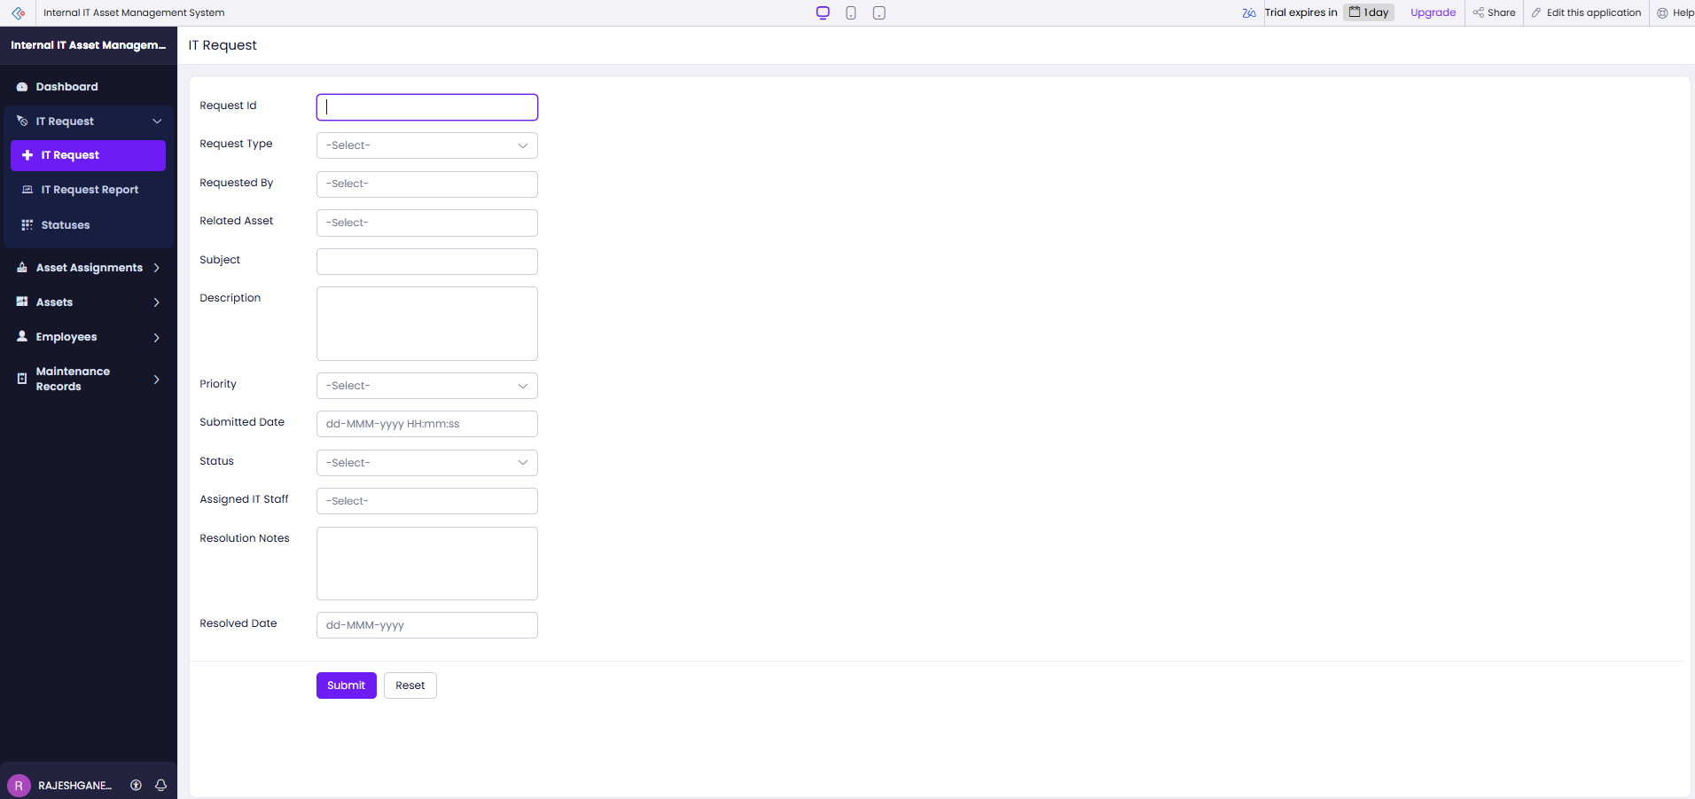
Figure 5.2: IT Request Form

Asset Assignment Form
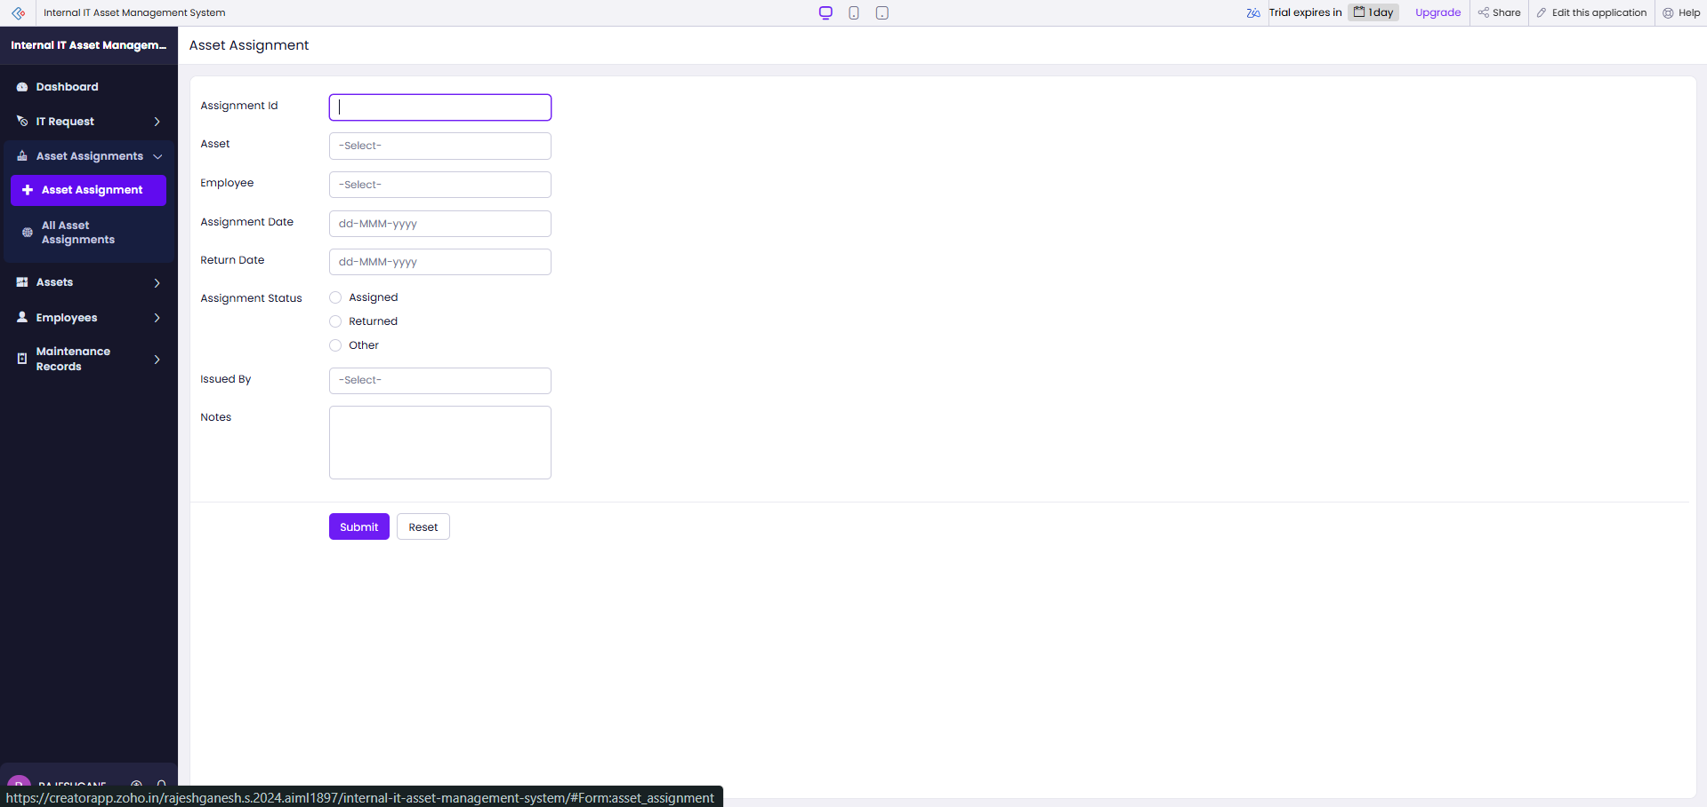
Asset Form
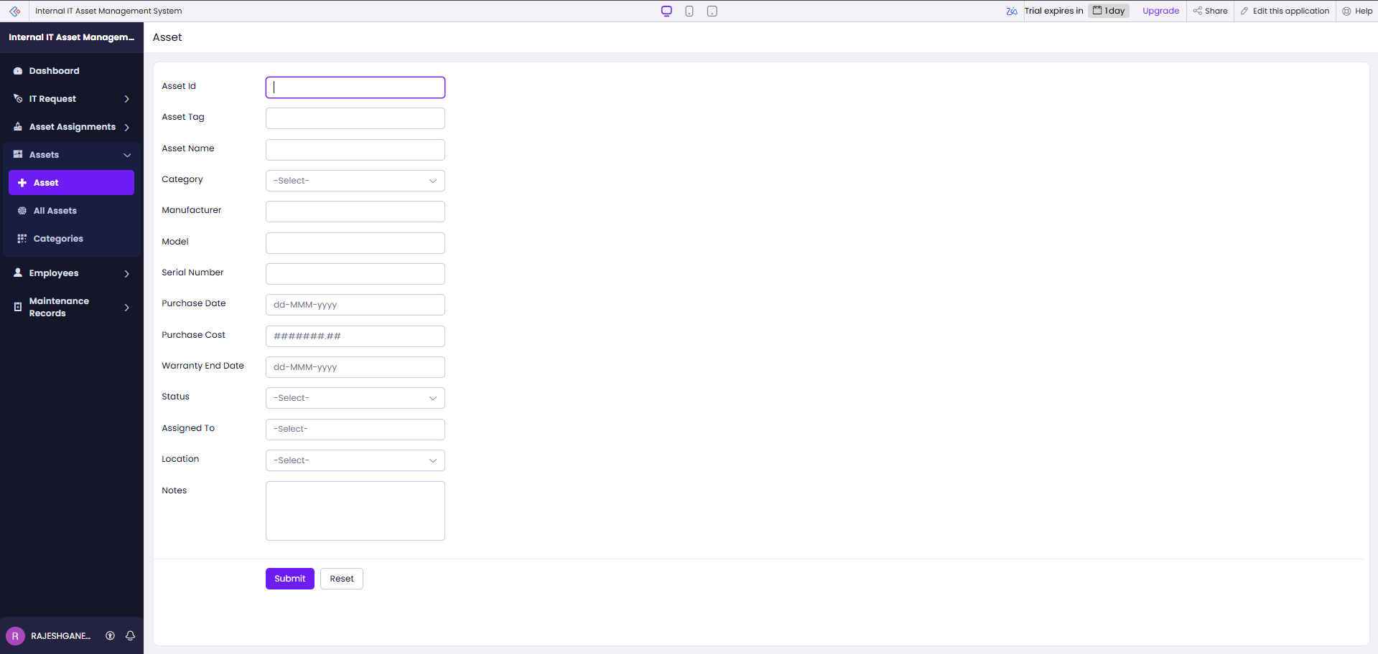
Figure 5.3: Asset Assignment and Asset Forms

5.3 Reports
The application defines eight reports: IT Request Report, IT Request by Status, Asset Assignment Report, Asset Report, Asset by Category, Employee Report, Employee by Department, Maintenance Record Report and Maintenance Record by Maintenance Type. The screenshots show list reports, category and department boards, and a status board. The dashboard displays purchase-cost summaries, request and assignment counts, request priority counts, and asset purchase cost by status and category. These are descriptive views over the sample records; no performance benchmark or custom action is evidenced.
Table 5.1: Reports Implemented in the Application
Report Name | Type | Source Form | Filter / Grouping / Sorting | Custom Actions | Roles
IT Request Report | List | IT Request | Status and priority shown | None evidenced | Access not verified
IT Request by Status | Kanban / grouped | IT Request | Grouped by status | Status board shown | Access not verified
Asset Assignment Report | List | Asset Assignment | Assignment date and status shown | None evidenced | Access not verified
Asset Report / Asset by Category | List / grouped | Asset | Status, category and purchase cost | Cost/category chart shown | Access not verified
Employee / Department / Maintenance reports | List / grouped | Employee / Maintenance | Grouped by department or type | None evidenced | Access not verified

IT Request Report
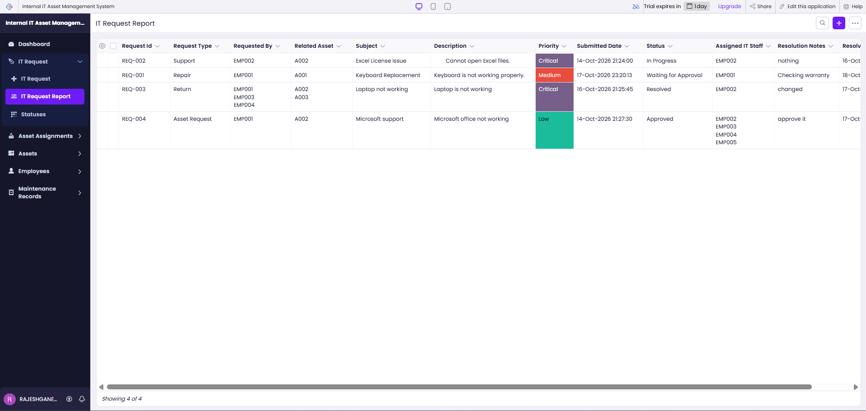
Asset Assignment Register
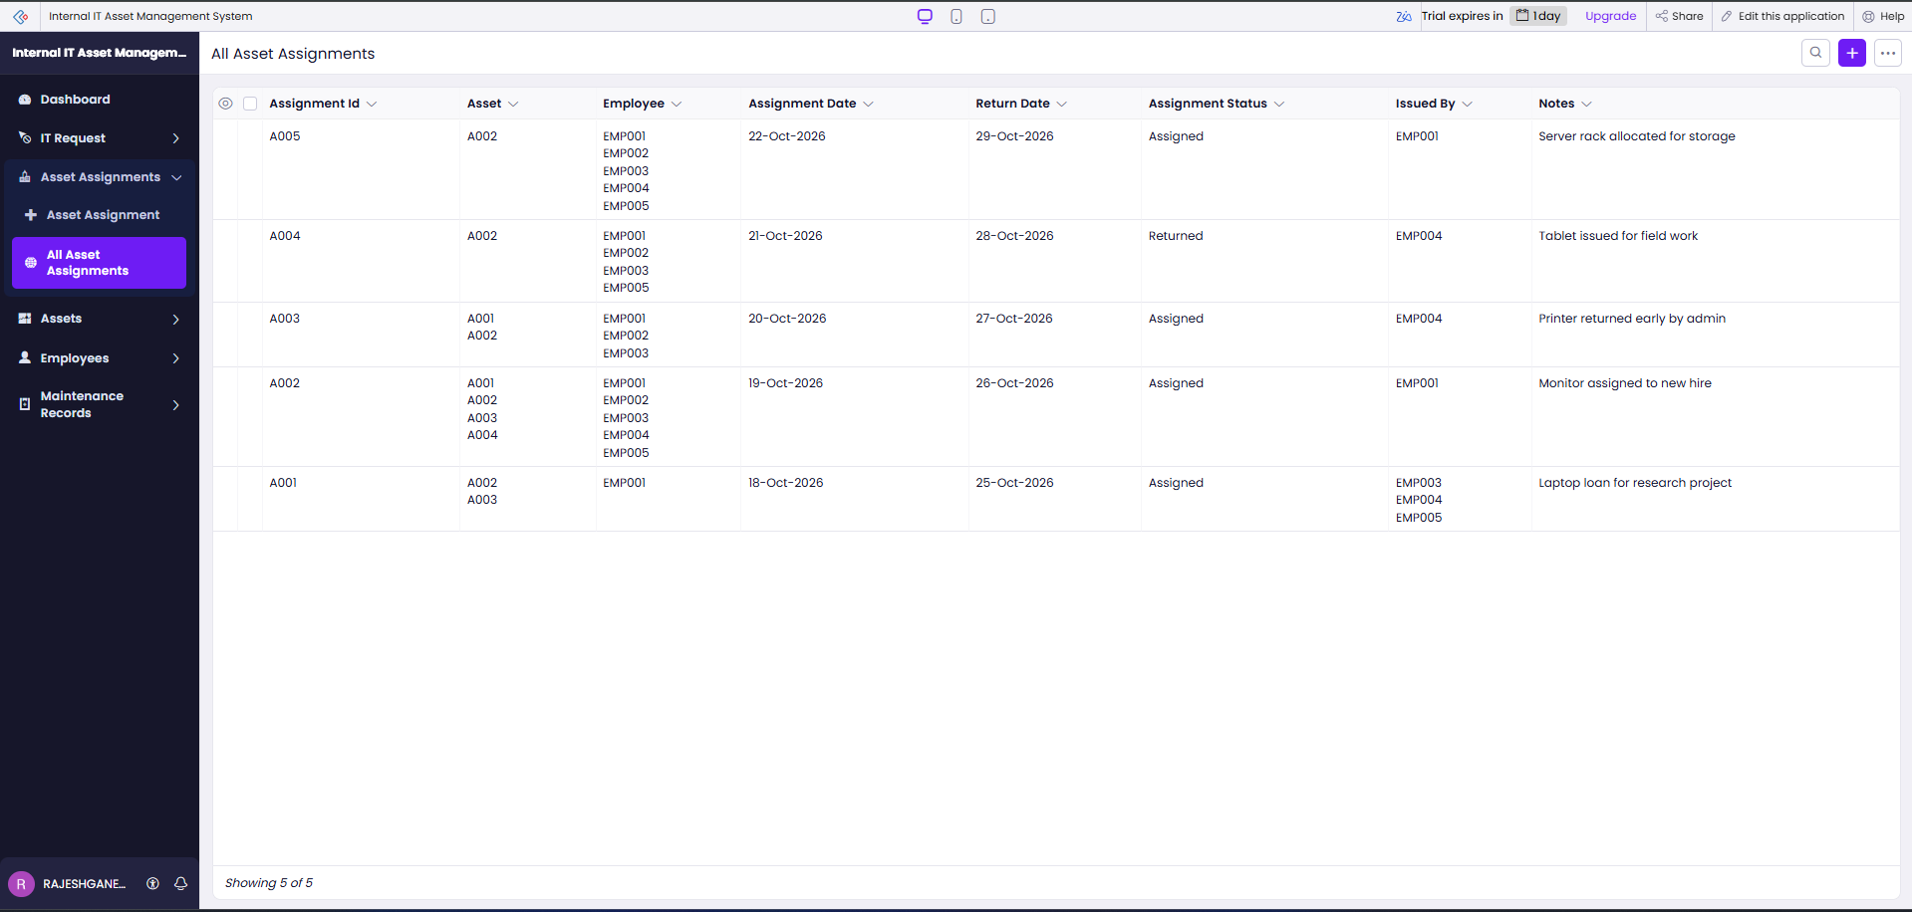
Figure 5.4: Request and Assignment Reports

5.4 Pages and Dashboards
The Dashboard page combines four summary panels, request-priority counts, charts for asset costs by status and category, quick links, and an IT Request Report. The page gives administrators and IT staff a high-level view of the sample data. The exact permission audience is not established by the supplied evidence.
Not evidenced

Asset Inventory
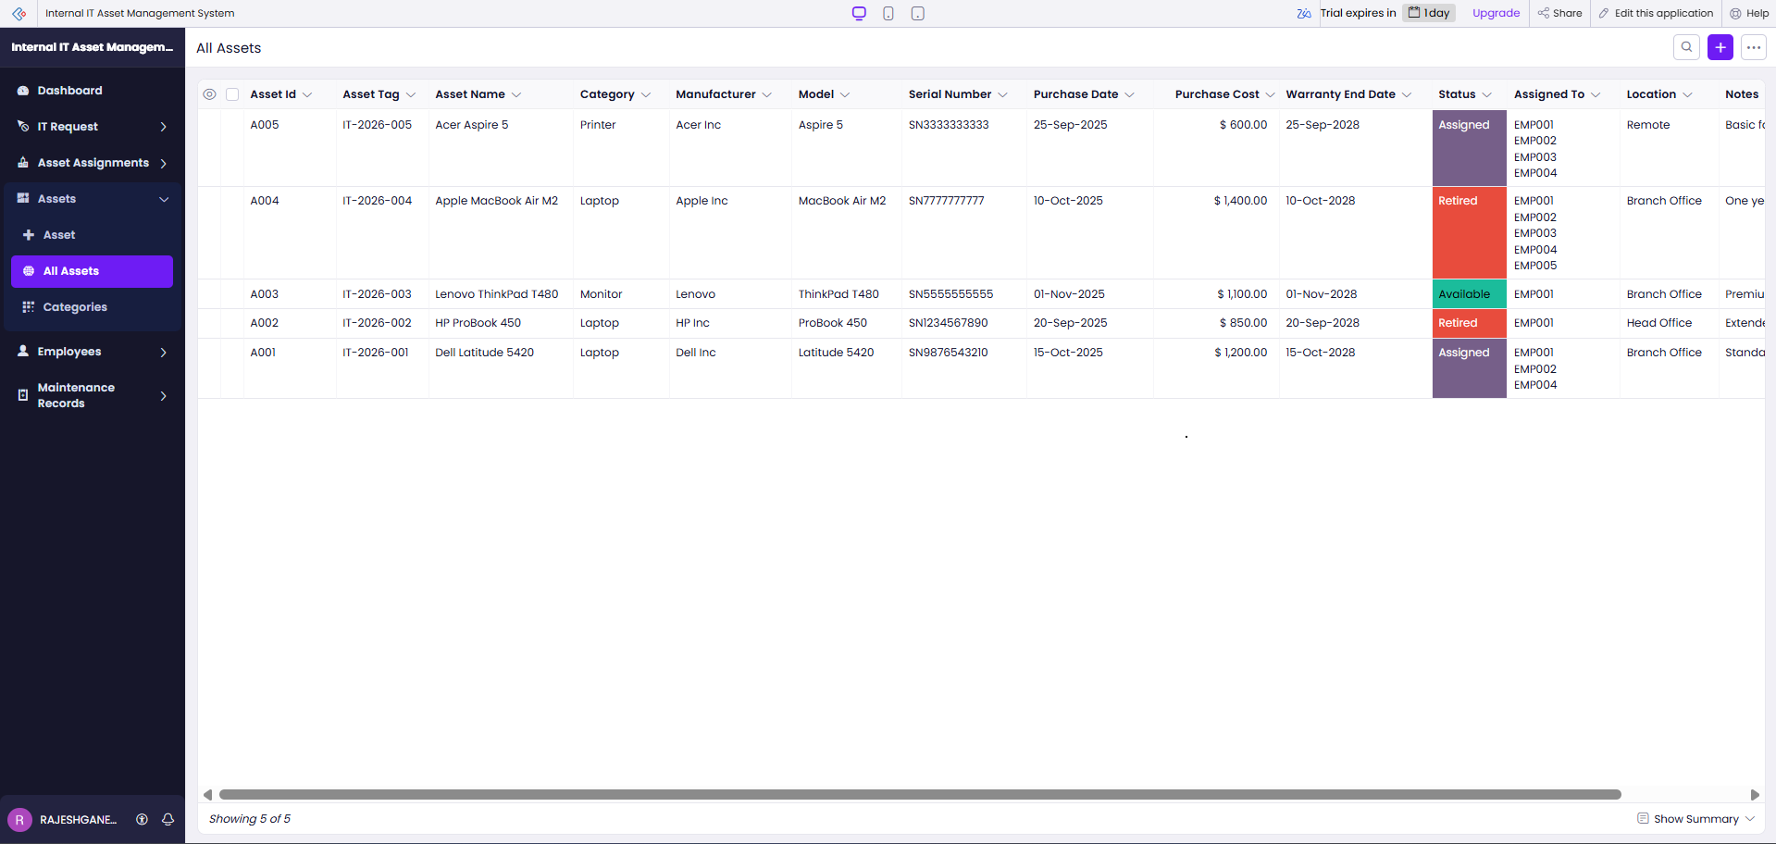
Asset Categories
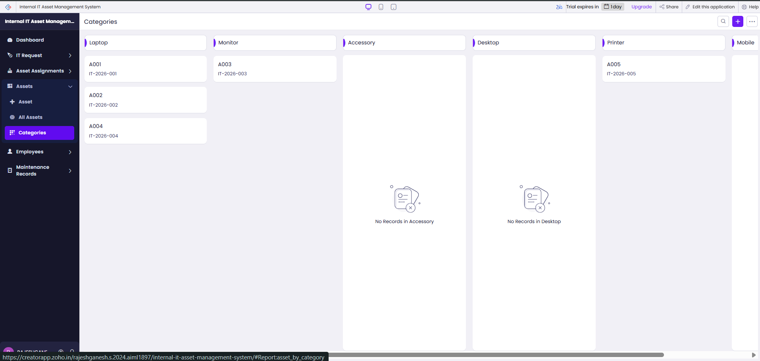
Figure 5.5: Dashboard and Asset Categories

5.5 Deluge Scripting
The exported application includes Deluge scripts in two automations. The asset-assignment form workflow checks whether an edited assignment has Returned status, retrieves the related employee and manager, and emails the manager when a manager email is present. The warranty schedule selects assets whose warranty end date falls within the next 30 days and emails assigned employees, falling back to the logged-in user when no employee email is available. The code excerpts summarize the exported logic; no separate validation script or API integration was found.
Table 5.2: Deluge Scripts Implemented
Script ID | Location / Trigger | Purpose | Deluge Concepts Used
DS-01 | Asset Assignment → On Edit → On Success | If status is Returned, retrieve employee, manager and asset, then email manager if address is present. | Record criteria, related-record fetch, condition, sendmail
DS-02 | Asset → Warranty End Date schedule at 10:00 Asia/Kolkata | Find assets with warranty ending in next 30 days and email assigned employees; use login user as fallback. | Date criteria, loop, list collection, sendmail
DS-03 | No separate function evidenced | No standalone function identified in supplied export. | Not applicable
Not evidenced | Not evidenced | Not evidenced | Not evidenced
Not evidenced | Not evidenced | Not evidenced | Not evidenced

Code 5.1: Notify the manager after an asset return
// DS-01 | Asset Assignment | On Edit: On Success
assetAssignment = asset_assignment[assignment_status == "Returned" && ID == input.ID];
if(assetAssignment.count() > 0)
{
employeeRecord = employee[ID == assetAssignment.employee.ID];
managerEmail = employeeRecord.manager;
if(!managerEmail.isNull() && !managerEmail.isEmpty())
{
assetRecord = asset[ID == assetAssignment.asset.ID];
subject = "Asset Returned: " + assetRecord.asset_name;
message = "<p>An asset has been returned.</p>";
message = message.concat("<p>Asset: " + assetRecord.asset_name + "</p>");
sendmail [ from :zoho.loginuserid to :managerEmail subject :subject message :message content type :HTML ];
}
}

Code 5.2: Send a warranty expiry reminder
// DS-02 | Asset | Warranty End Date schedule at 10:00 Asia/Kolkata
warrantyExpiringAssets = asset[warranty_end_date in next 30 days];
for each assetRecord in warrantyExpiringAssets
{
assignedEmployeeEmails = List:String();
if(!assetRecord.assigned_to.isNull())
{
employeeRecords = employee[ID in assetRecord.assigned_to];
for each employeeRecord in employeeRecords
{
if(!employeeRecord.email.isNull()) assignedEmployeeEmails.add(employeeRecord.email);
}
}
recipientEmails = zoho.loginuserid;
if(assignedEmployeeEmails.size() > 0) recipientEmails = assignedEmployeeEmails.toString(",");
sendmail [ from :zoho.loginuserid to :recipientEmails subject :"Warranty Expiry Alert - " + assetRecord.asset_name message :"Warranty ends on " + assetRecord.warranty_end_date.toString("dd MMM yyyy") ];
}

The first script runs after an Asset Assignment edit and sends a message only when the assignment is marked Returned and a manager email is available. The second script is attached to the warranty date schedule and checks the next-30-days window before sending a reminder. The supplied screenshots show the workflow and schedule enabled. They do not include execution logs or delivery receipts, so runtime success is not independently verified.

5.6 Workflows and Automation
The export defines a form workflow named “Notify Manager on Asset Return,” triggered after editing an Asset Assignment. It also defines the “Warranty Expiry Reminder” schedule on Asset, based on Warranty End Date at 10:00 in Asia/Kolkata. The export includes an Asset Maintenance Lifecycle blueprint and stage definitions for IT Requests. Screenshots show the form workflow, schedule and maintenance blueprint enabled. No separate approval workflow is evidenced.
Table 5.3: Workflows and Blueprint Processes
Workflow Name | Type | Trigger / Event | Condition | Action(s) | Script Ref.
Notify Manager on Asset Return | Form workflow | Asset Assignment edited; On Success | Status = Returned; manager email present | Email asset, employee, return date and notes | DS-01
Warranty Expiry Reminder | Schedule | Warranty End Date at 10:00 Asia/Kolkata | Warranty date in next 30 days | Email assigned employee addresses; fallback to logged-in user | DS-02
IT Request lifecycle | Blueprint stage configuration | Request record lifecycle | Stages defined in export | Submission, manager approval, IT assignment, progress and closure stages | Blueprint stages
Asset Maintenance Lifecycle | Blueprint | Maintenance Record lifecycle | Starts at Maintenance Request Created | Review, approval, parts, technician assignment and maintenance progress | Blueprint
Not evidenced | Not evidenced | Not evidenced | Not evidenced | Not evidenced | Not evidenced

Asset Return Workflow
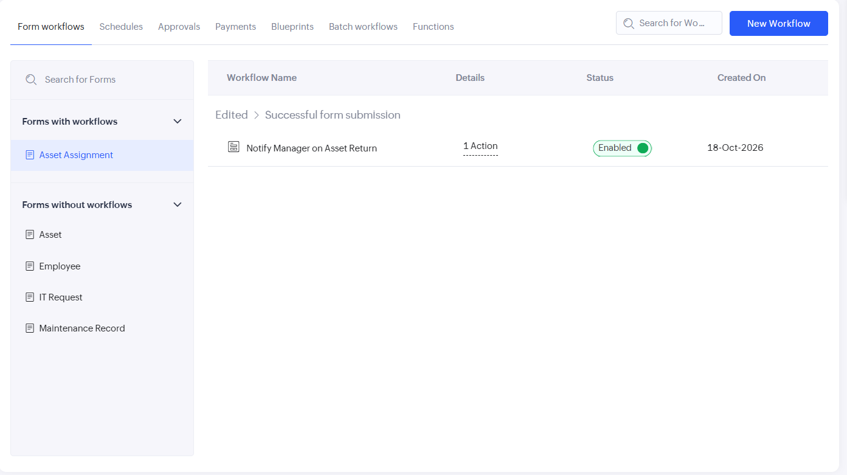
Warranty Reminder Schedule
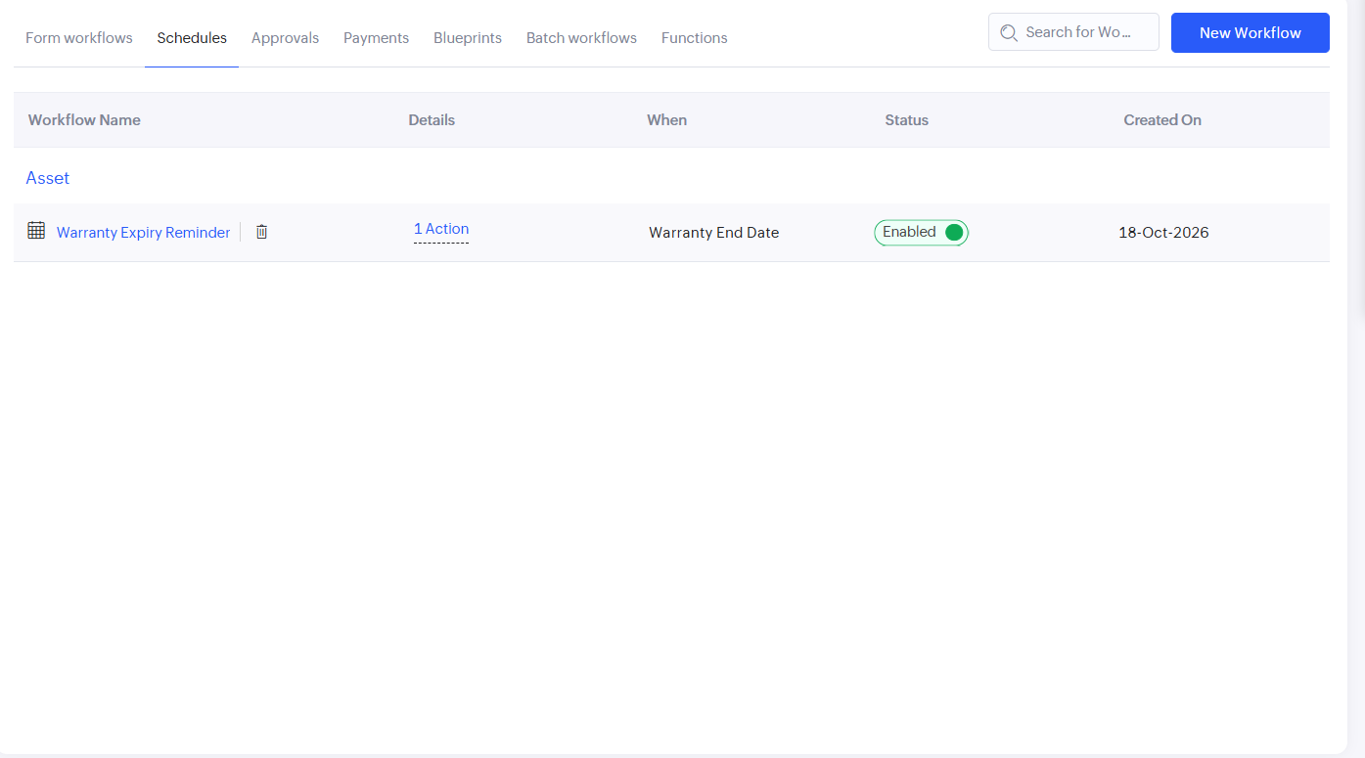
Maintenance Lifecycle Blueprint
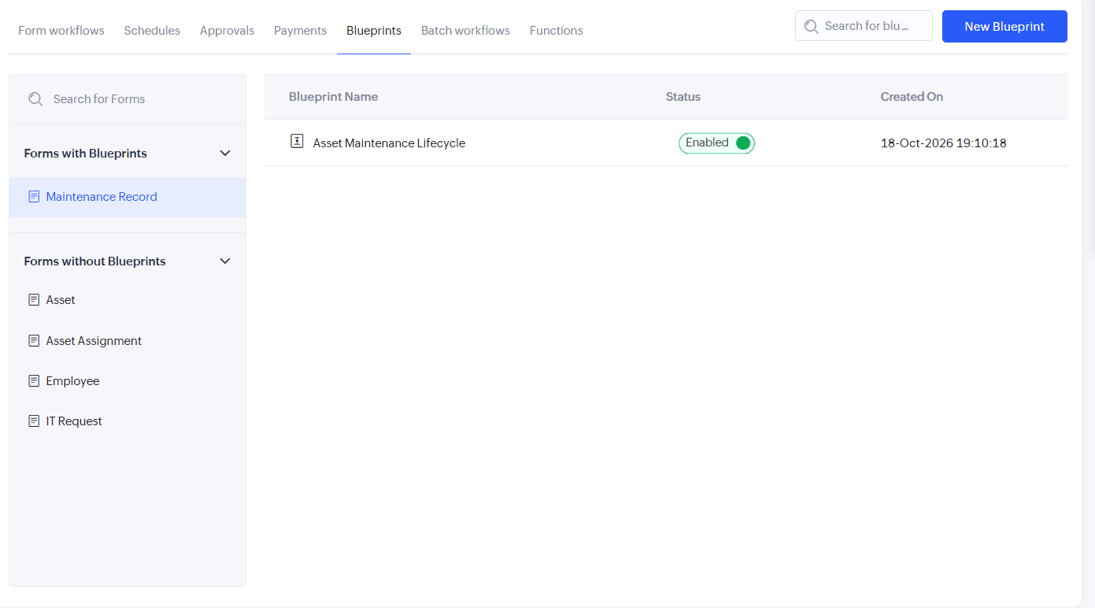
Figure 5.6: Request Status, Employee and Workflow Configuration

5.7 Integrations
No external service integration, Creator REST API call, invokeurl call or Postman response is present in the supplied export. The workflow uses Creator’s built-in sendmail action. Zoho Mail, CRM, Sheets, Catalyst and external APIs are not reported as integrated.
Table 5.4: Integrations Implemented
Integration | Service / Endpoint | Method | Authentication | Data Exchanged / Purpose
Built-in email action | Zoho Creator sendmail | Workflow and schedule actions | Creator logged-in identity | Manager return notice and warranty reminder
External integration | None evidenced | None evidenced | Not applicable | No external exchange in supplied export
Creator API / webhook | None evidenced | None evidenced | Not applicable | No API or webhook supplied

Code 5.3: No external integration script is included in the supplied export.
No external integration script is included in the supplied project export.

Not evidenced
Figure 5.7: No External Integration Configuration Supplied

5.8 User Management and Role-Based Access
The Employee form stores a role value and manager name, while the application screens show signed-in access to the Creator application. The supplied export and screenshots do not show user invitations, permission profiles, record-level rules, portal configuration or field-level restrictions. Table 4.3 therefore records a recommended permission matrix for verification, not a claim that it is already enforced.
Not evidenced

Employee Form and Role Field
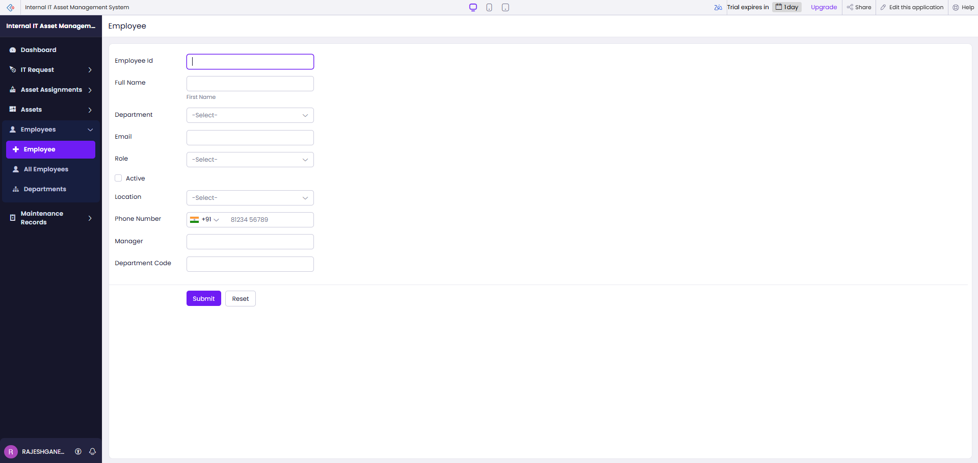
Employees by Department
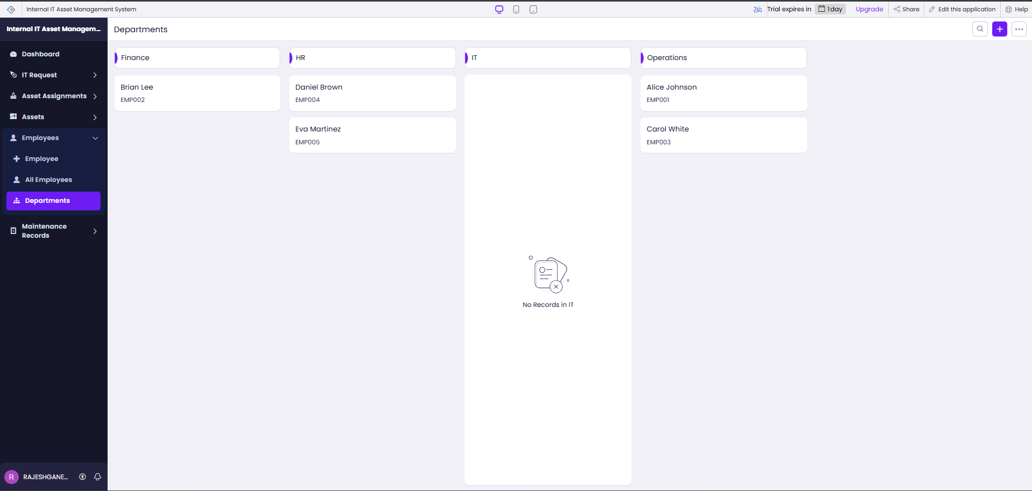
Figure 5.8: Employee Role Form and Department Report

5.9 AI and Analytics Features
The dashboard includes count and cost summaries and bar charts for purchase cost by asset status and category. The supplied export does not evidence Zia, AI-generated fields, prediction, OCR, sentiment analysis or a Zoho Analytics connection. The analytics discussion is limited to the Creator dashboard and reports shown in the screenshots.
Not evidenced

Dashboard Charts
Figure 5.9: Dashboard Charts and Cost Summaries

5.10 Pro-Code Extension
No pro-code extension, Catalyst service, custom JavaScript widget or Creator REST API endpoint is evidenced in the export. For this project’s current scope, Creator forms, reports, Deluge, workflow and blueprint configuration provide the demonstrated functions. A separate service could be considered if future requirements exceed Creator’s scripting or integration capabilities.
Not evidenced

5.11 Mobile and Portal Access
The supplied screenshots document the web application. Mobile layout, offline use and customer portal access were not tested or documented for this project.

Employee Directory
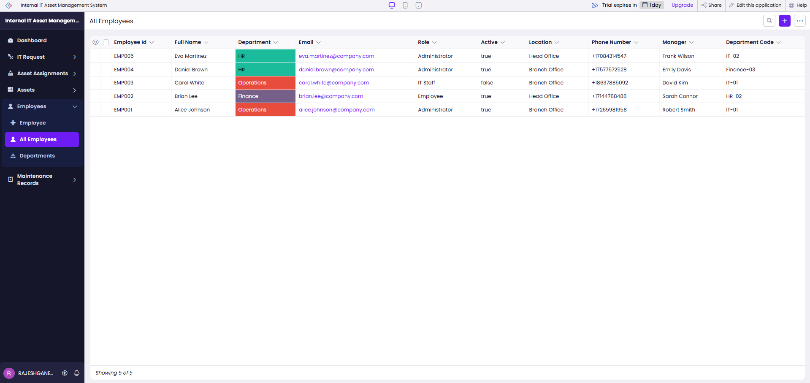
Figure 5.10: Employee Directory; Mobile and Portal Access Not Verified
CHAPTER 6

TESTING AND DEBUGGING

6.1 Testing Strategy
Verification should cover required and invalid form inputs, lookup relationships, report content, workflow triggers, schedule criteria, Blueprint transitions and access permissions. The supplied screenshots confirm that sample data appears in the reports and dashboard, and that the workflow, schedule and blueprint are shown as enabled. They do not constitute a complete test log. The cases in Table 6.1 are a verification plan; results remain “Not recorded” unless a screenshot or export directly demonstrates the result.
Not evidenced

6.2 Test Cases
The following test cases are derived from the functional requirements. The provided materials do not include a completed execution log, so actual results and pass status are not invented.
Table 6.1: Functional and Workflow Test Cases
TC ID | FR Ref. | Test Description | Input / Steps | Expected Result | Actual Result | Status
TC-01 | FR-01 | Create an asset record | Enter asset identity, category and status; submit. | Asset appears in Asset Report. | Sample records visible in screenshot; no execution log. | Evidence shown
TC-02 | FR-02 | Create an employee record | Enter employee ID, name, department and role; submit. | Employee appears in Employee Report. | Sample rows visible in screenshot. | Evidence shown
TC-03 | FR-03 | Record an assignment | Select asset and employee; enter date and status; submit. | Assignment appears in report. | Sample rows visible in screenshot. | Evidence shown
TC-04 | FR-04 | Review request status board | Open IT Request by Status report. | Requests appear in status columns. | Sample cards visible in screenshot. | Evidence shown
TC-05 | FR-05 | Review maintenance records | Open Maintenance Record report. | Records show type, asset, status and cost. | Sample records visible in screenshot. | Evidence shown

6.3 Debugging Deluge Scripts
No Deluge debug output or defect history was included. A repeatable debugging approach is to inspect form-workflow criteria, verify related employee and asset lookups, confirm manager email is present, review the workflow execution log, and test schedule dates inside and outside the 30-day window. A defect and fix are not claimed without a recorded example.
Not evidenced

IT Request Status Board
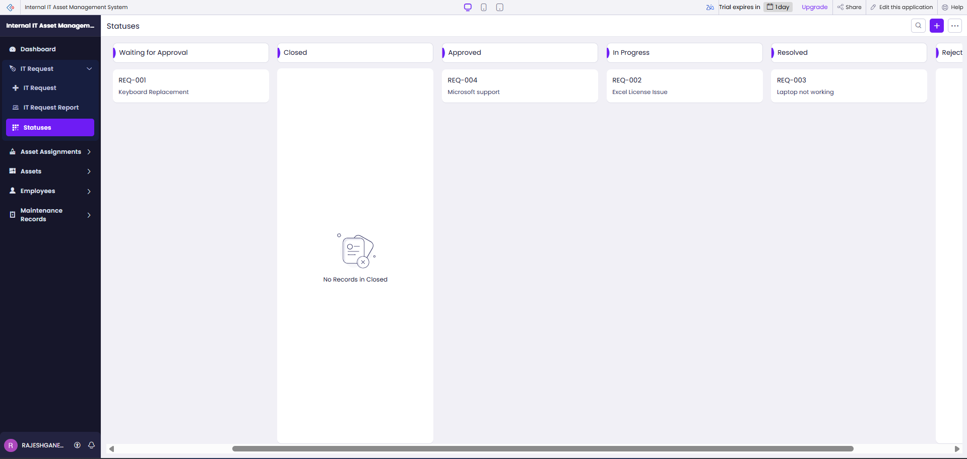
Figure 6.1: Request Status Board; No Debug Log Supplied

6.4 Defect Log
Table 6.2: Defect Log
Bug ID | Description | Root Cause | Fix Applied | Status
Not recorded | No defect log supplied. | Not available | Capture issues and fixes during testing. | Not documented

6.5 User Acceptance Testing
No user acceptance feedback was supplied. Record this section after two or more users complete role-specific tasks and provide feedback.
Table 6.3: User Acceptance Feedback
User | Role Tested | Feedback | Action Taken
Not recorded | Not recorded | No UAT feedback supplied. | Conduct and document UAT before deployment.
CHAPTER 7

DEPLOYMENT, SECURITY AND GOVERNANCE

7.1 Environments and Deployment Strategy
The exported application and live screenshots demonstrate a working Creator application interface. No Development-to-Stage-to-Production promotion record, published release date, rollback plan or environment configuration was supplied. The checklist marks such items as unverified. Before production use, test the app in a non-production environment, confirm permissions and email recipients, and record the release and rollback steps.
Not evidenced

Live Application Dashboard
Figure 7.1: Live Dashboard; Environment History Not Supplied
Table 7.1: Deployment Checklist
S.No. | Checklist Item | Done (✓)
1 | Test cases executed in Development / Stage | Not evidenced
2 | Sample/test data removed or isolated | No; screenshots show demonstration records
3 | Roles, permissions and users configured in Production | Not evidenced
4 | Connections authorized in Production | Not applicable / not evidenced
5 | Schedules and workflows enabled | Enabled status shown; execution not verified
6 | Application published and URL verified | Live app screenshots supplied; deployment history not documented
7 | Version / release notes recorded | Not evidenced

7.2 Performance Optimisation
No before-and-after timing measurements or optimization log were supplied. The application provides grouped views and a dashboard over a small sample dataset, but the report does not claim response-time improvements. Performance should be measured with representative record volumes before deployment.

Table 7.2: Performance Optimisation Results
Optimisation Applied | Component | Before | After | Improvement
No measured optimization supplied | Dashboard and reports | Not measured | Not measured | No performance gain claimed
No benchmark supplied | Application data volume | Sample records shown | Production volume unknown | Measure before release

7.3 Security Features
The employee form has a role field, and email actions use the Creator login identity. The provided project files do not verify configured permission profiles, record-level rules, encrypted fields, IP restrictions, multi-factor requirements or audit settings. These must be reviewed in Creator before the application is used with real employee or asset data.
Table 7.3: Security Controls Implemented
Security Control | Where Applied | Threat Mitigated
Creator role/profile permissions | Not verified | Review access before use
Sensitive field encryption | Not evidenced | Assess protection of personal and asset data
Workflow sender identity | sendmail uses zoho.loginuserid | Avoid hard-coded sender credentials; verify configuration
Audit and record history | Not verified | Enable/review for accountability

7.4 Governance and Administration
The application uses named forms, reports and workflow components visible in the export. The supplied files do not show backup schedules, change approvals, audit-trail settings, license management or production ownership. These items should be assigned and documented as part of deployment governance.
Not evidenced

No audit-trail or administration screenshot was supplied. The maintenance Blueprint is shown in Figure 5.6.
Figure 7.2: Audit Trail Not Verified; Blueprint Shown in Figure 5.6
CHAPTER 8

RESULTS AND DISCUSSION

8.1 Application Output
The screenshots illustrate the end-to-end data views. An IT team can register assets and employees, record an assignment, submit an IT request, follow requests through status stages, and create maintenance records linked to assets. The dashboard consolidates sample purchase costs and counts. The examples are demonstration records and are not measured pilot results.
The dashboard displays headline metrics and charts alongside the request report and quick links.

Scenario Step 1 Dashboard
Figure 8.1: Maintenance Record Form

Scenario Step 2 Assignment and Inventory
Asset Inventory
Figure 8.2: Workflow Configuration

Scenario Step 3 Maintenance Records
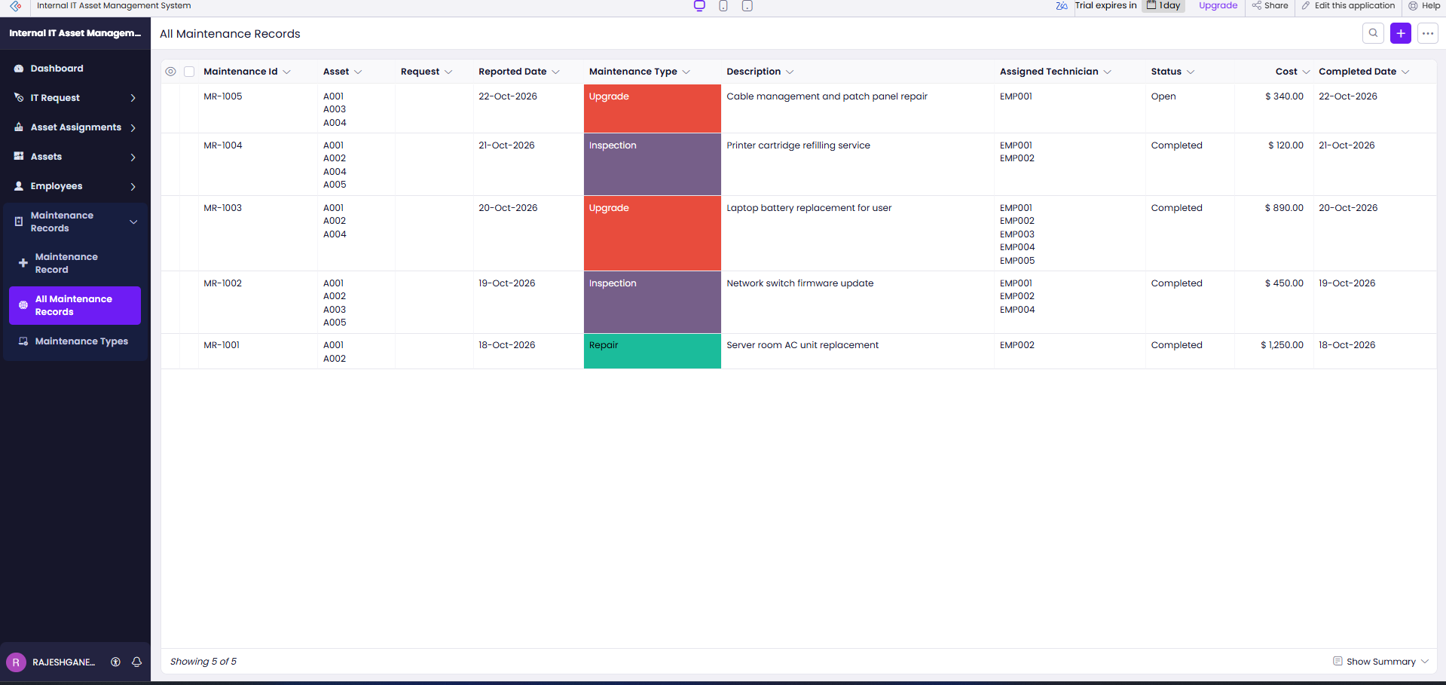
Maintenance Type View
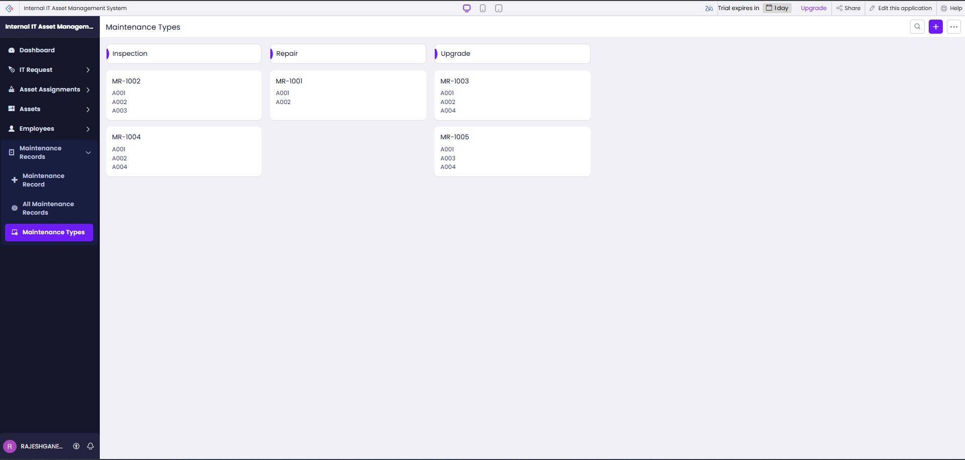
Figure 8.3: Maintenance Type Board

8.2 Achievement of Objectives
Table 8.1: Mapping of Objectives to Outcomes
Objective (Sec. 1.3) | Implemented Through | Outcome / Evidence
Create structured operational records | Five Creator forms | Five form types confirmed in export and screenshots.
Represent process status and automation | Form workflow, schedule and Blueprint stages | Configuration present in export; enabled components shown.
Provide reports and summaries | Eight reports and Dashboard page | Reports and dashboard visible with sample data.

8.3 Comparison with the Existing System
Table 8.2: Existing System versus Proposed Application
Parameter | Existing System | Proposed Application | Improvement
Record access | Separate files assumed for baseline | Related Creator forms and reports | Centralized in demonstrated app; quantitative gain not measured
Manual steps | Manual follow-up assumed for baseline | Return notification and warranty schedule | Automation configured; execution not verified
Report generation | Manual summary assumed for baseline | Eight reports and dashboard | Views preconfigured; time saved not measured
Data accessibility | Distributed records assumed | Creator web interface | Shared interface demonstrated; role access not verified

8.4 Limitations of the Low-Code Approach
The project depends on Zoho Creator’s data model, report types, workflow configuration and Deluge runtime. This can make the application faster to configure for the current forms and reports, but it also ties the implementation to Creator concepts and services. Complex interfaces, very high-volume processing, advanced integration orchestration and custom analytics may require external services or pro-code extensions. The project files do not document a platform limit encountered during implementation, so these are design considerations rather than observed defects.
Not evidenced

8.5 Reflection on the No-Code → Low-Code → Pro-Code Spectrum
The forms, reports, dashboard layout, picklist options and process stages are primarily visual configuration. The manager notification and warranty reminder require low-code Deluge logic. A custom mobile client, advanced API integration or high-volume analytics service would move selected components toward pro-code development. The appropriate boundary depends on future requirements for scale, external connectivity, portability and specialized user experience.
Not evidenced
CHAPTER 9

CONCLUSION AND FUTURE ENHANCEMENTS

9.1 Conclusion
The project delivers a Zoho Creator application for internal IT asset and service administration. Its five forms represent assets, employees, assignments, requests and maintenance records. Eight reports and a dashboard provide list, grouped and summary views of sample data. The supplied export also defines an asset-return manager notification, a warranty reminder schedule and process stages for request and maintenance lifecycles. Available evidence demonstrates the configuration and sample screens, while formal testing, permission-profile verification and production deployment remain to be documented.
Not evidenced

9.2 Future Enhancements
- Configure and verify Creator permission profiles and record-level access for administrators, managers, IT staff and employees.
- Complete a test log and user acceptance review, including negative tests and workflow email-delivery checks.
- Evaluate integrations, mobile access and predictive warranty or maintenance analytics after requirements and data governance are defined.

9.3 Learning Outcomes and Career Relevance
The project provided practical experience with low-code form modeling, lookup relationships, reports, dashboards, Deluge scripting and workflow stages. These skills are relevant to low-code application development, business analysis and workflow automation roles. Further work on access control, testing, deployment governance and integration design would strengthen the application for operational use.
Not evidenced

REFERENCES
References are listed in IEEE style and cited in the report.
[1] D. Gao, F. Fagerholm, and V. Toivanen, “What does current research say about the viability of low-code development? A systematic literature review,” Journal of Systems and Software, vol. 239, art. 112893, 2026, doi: 10.1016/j.jss.2026.112893.
[2] M. O. Ajimati, N. Carroll, and M. Maher, “Adoption of low-code and no-code development: A systematic literature review and future research agenda,” Journal of Systems and Software, vol. 222, art. 112300, 2025, doi: 10.1016/j.jss.2024.112300.
[3] Zoho Corporation, “A Quickstart Guide to Zoho Creator,” Zoho Creator Help. [Online]. Available: https://www.zoho.com/creator/help/new-quickstart-guide.html. Accessed: 19 Oct. 2026.
[4] Zoho Corporation, “Understanding workflows,” Zoho Creator Help. [Online]. Available: https://help.zoho.com/portal/en/kb/creator/developer-guide/workflows/understand-workflows/articles/understand-workflows. Accessed: 19 Oct. 2026.
[5] Zoho Corporation, “Creating blueprints,” Zoho Creator Help. [Online]. Available: https://help.zoho.com/portal/en/kb/creator/developer-guide/workflows/blueprints/articles/create-a-blueprint. Accessed: 19 Oct. 2026.

APPENDIX A – ZOHO CREATOR FEATURE COVERAGE CHECKLIST
This checklist distinguishes features evidenced by the supplied .ds export and screenshots from features not verified in those materials.
Table A.1: Feature Coverage Checklist
Unit | Zoho Creator Feature | Done | Where in the Application | Report Section | Figure / Code No.
I | Application created & sections/menu organised | Yes | Dashboard and six menu groups | 5.1 | Fig. 5.1
II | Forms with ≥ 8 distinct field types | Yes | Five forms; multiple field types | 5.2 | Tables 4.2, Fig. 5.2–5.3
II | Lookup field (relationship between forms) | Yes | Asset, Employee and Request list fields | 4.2, 5.2 | Table 4.1
II | Subform (parent–child data) | No evidence | Not found in supplied export/screenshots | 4.2, 5.2 | —
II | Field validations / layout rules | No evidence | Not found in supplied export/screenshots | 5.2 | —
II | List report with filter, grouping, custom action | No evidence | Not found in supplied export/screenshots | 5.3 | —
II | Kanban / Calendar / Timeline / Map report | No evidence | Not found in supplied export/screenshots | 5.3 | —
II | Pivot table / chart report | No evidence | Not found in supplied export/screenshots | 5.3 | —
II | Page / dashboard built with UI Builder | Yes | Dashboard page | 5.4 | Fig. 5.5
II | Deluge – form events (validate / success / field actions) | No evidence | Not found in supplied export/screenshots | 5.5 | —
II | Deluge – functions, fetch, loops, collections | No evidence | Not found in supplied export/screenshots | 5.5 | —
II | Email / in-app notifications | Partial | Return notice and warranty reminder configured | 5.5, 5.6 | DS-01, DS-02
II | Form workflow | Yes | Notify Manager on Asset Return | 5.6 | Fig. 5.6
II | Scheduled workflow | Yes | Warranty Expiry Reminder | 5.6 | Fig. 5.6
II | Approval process | No evidence | Not found in supplied export/screenshots | 5.6 | —
II | Blueprint | Yes | Maintenance lifecycle and IT Request stages | 5.6 | Fig. 5.6
II | Batch / report workflow | No evidence | Not found in supplied export/screenshots | 5.6 | —
II | Testing & debugging evidence | Partial | Screenshots show sample outputs; no test log | 6 | Table 6.1
III | Integration with a Zoho service | No evidence | Not found in supplied export/screenshots | 5.7 | —
III | Connection / REST API call (invokeurl) | No evidence | Not found in supplied export/screenshots | 5.7 | —
III | Webhook or Creator REST API | No evidence | Not found in supplied export/screenshots | 5.7 | —
III | Users, roles and permission profiles | No evidence | Not found in supplied export/screenshots | 5.8 | —
III | Record-level access criteria / customer portal | No evidence | Not found in supplied export/screenshots | 5.8 | —
III | Zia / AI feature | Partial | Role values shown; permission profiles unverified | 5.9 | Fig. 5.8
III | Analytics (charts / Zoho Analytics) | No evidence | Not found in supplied export/screenshots | 5.9 | —
IV | Performance optimisation applied & measured | No evidence | Not found in supplied export/screenshots | 7.2 | —
IV | Deployment across environments | Partial | Creator charts shown; no Zoho Analytics | 7.1 | Fig. 5.5
IV | Security controls (encryption, OAuth, permissions) | No evidence | Not found in supplied export/screenshots | 7.3 | —
IV | Governance (audit trail, administration) | No evidence | Environment promotion not documented | 7.4 | —
V | Pro-code extension (Catalyst / widgets / custom functions) | No evidence | Not found in supplied export/screenshots | 5.10 | —
V | Low-code limitations & spectrum analysis | No evidence | Not found in supplied export/screenshots | 8.4, 8.5 | —
— | Mobile app / portal access | No evidence | Not found in supplied export/screenshots | 5.11 | —

Total evidenced features: 12 / 32; remaining items are not evidenced or are not applicable to the supplied implementation.

APPENDIX B – COURSE OUTCOME MAPPING
Course outcome evidence is mapped to the report sections listed in the table. Self-assessment should be reviewed by the student and examiner.
Table B.1: Mapping of Course Outcomes to Report Chapters
CO | Course Outcome Statement | Evidenced In | Self-Assessed Level | Examiner Level
CO1 | Explain low-code development principles and value | Ch. 1, 2 | Review by student
CO2 | Develop forms, reports, workflows and Deluge scripts | Ch. 4, 5, Appendix C | Review by student
CO3 | Integrate services and apply role-based security | Ch. 4.6, 5.7–5.8; gaps identified | Review by student
CO4 | Deploy, secure and govern Creator applications | Ch. 7; requirements and evidence gaps | Review by student
CO5 | Evaluate low-code, AI-assisted development and pro-code transition | Ch. 5.9–5.10, 8.4–8.5 | Review by student

APPENDIX C – COMPLETE DELUGE SOURCE CODE
The exported source establishes the workflow and schedule logic described in Chapter 5. Complete source snippets are reproduced below where identifiable in the supplied export.
C.1 Asset Assignment Workflow – Notify Manager on Asset Return
// DS-01 | Asset Assignment | On Edit: On Success
assetAssignment = asset_assignment[assignment_status == "Returned" && ID == input.ID];
if(assetAssignment.count() > 0)
{
employeeRecord = employee[ID == assetAssignment.employee.ID];
managerEmail = employeeRecord.manager;
if(!managerEmail.isNull() && !managerEmail.isEmpty())
{
assetRecord = asset[ID == assetAssignment.asset.ID];
subject = "Asset Returned: " + assetRecord.asset_name;
message = "<p>An asset has been returned.</p>";
message = message.concat("<p>Asset: " + assetRecord.asset_name + "</p>");
sendmail [ from :zoho.loginuserid to :managerEmail subject :subject message :message content type :HTML ];
}
}

C.2 Asset Warranty Expiry Reminder Schedule
// DS-02 | Asset | Warranty End Date schedule at 10:00 Asia/Kolkata
warrantyExpiringAssets = asset[warranty_end_date in next 30 days];
for each assetRecord in warrantyExpiringAssets
{
assignedEmployeeEmails = List:String();
if(!assetRecord.assigned_to.isNull())
{
employeeRecords = employee[ID in assetRecord.assigned_to];
for each employeeRecord in employeeRecords
{
if(!employeeRecord.email.isNull()) assignedEmployeeEmails.add(employeeRecord.email);
}
}
recipientEmails = zoho.loginuserid;
if(assignedEmployeeEmails.size() > 0) recipientEmails = assignedEmployeeEmails.toString(",");
sendmail [ from :zoho.loginuserid to :recipientEmails subject :"Warranty Expiry Alert - " + assetRecord.asset_name message :"Warranty ends on " + assetRecord.warranty_end_date.toString("dd MMM yyyy") ];
}

APPENDIX D – USER MANUAL
This user guide describes the main web tasks visible in the supplied application. Access depends on a Creator user account and permissions assigned by the application owner.

D.1 Accessing the Application
Open the Internal IT Asset Management System in Zoho Creator using the URL provided by the application owner. Sign in with your assigned account. Use the left navigation to open Dashboard, IT Request, Asset Assignments, Assets, Employees or Maintenance Records. The screenshots document web access; mobile and portal steps are not verified.

D.2 Instructions for IT Staff
- 1. Open Assets and choose Asset to register equipment. Enter its asset tag, name, category, manufacturer, dates, cost, status, location and notes, then submit.
- 2. Open Asset Assignment to record the asset, employee, assignment date and issuer. Use the Asset Assignment report to review assignment and return status.

D.3 Instructions for Employees and Managers
- 1. Open IT Request and enter request type, requester, related asset, subject, description, priority and submission details. Submit the form and refer to the request report for status.
- 2. Managers can review requests and assignment information using the reports. Approval permissions and notification delivery depend on configuration not verified in the supplied materials.

APPENDIX E – EVALUATION RUBRIC
(For Examiner Use Only)

Student Name | RajeshGanesh S | Register No. | 2116241501161
Project Title | Internal IT Asset Management System | Date | 21 October 2026

Table E.1: Evaluation Rubric for the Individual Project
S.No. | Criterion | Indicators | Max. Marks | Marks Awarded
1 | Problem Definition & Requirement Analysis | Clarity of problem, measurable objectives, complete FR/NFR, use cases | 10
2 | System Design | Architecture, ER/data model, form specifications, workflow design, permission matrix | 10
3 | Forms, Reports & Pages | Variety of field types, lookups/subforms, report types, UI Builder dashboards | 15
4 | Deluge Scripting & Workflows | Correctness and depth of scripts; form, schedule, approval, Blueprint, batch workflows | 15
5 | Integration, RBAC & AI | Zoho/external integrations, connections, roles & permissions, Zia/analytics | 10
6 | Testing, Deployment, Security & Governance | Test coverage, environments, optimisation, security controls, audit | 10
7 | Live Demonstration | End-to-end working of the application across roles; feature checklist verified | 15
8 | Project Report | Adherence to template and format, clarity, figures, references | 5
9 | Viva-Voce | Understanding of the platform, design decisions and low-code concepts | 10
 | TOTAL |  | 100

Table E.2: Performance Level Descriptors
Level | % of Max. Marks | Descriptor
Excellent | 90–100 | Feature implemented completely, correctly and beyond the basic requirement; student explains design choices confidently.
Good | 70–89 | Feature implemented correctly with minor gaps; explanation adequate.
Satisfactory | 50–69 | Feature partially implemented or works only for the main path; limited explanation.
Needs Improvement | < 50 | Feature missing, non-functional or not understood by the student.

Signature of Internal Examiner  Name: ____________________ | Signature of External Examiner  Name: ____________________

APPENDIX F – VIVA-VOCE RECORD SHEET
(For Examiner Use Only)
Student Name | RajeshGanesh S | Register No. | 2116241501161
Department / Section | Artificial Intelligence and Machine Learning | Date of Viva | To be completed
Application URL Verified | To be completed | Demo Duration | To be completed
Table F.1: Viva-Voce Questions and Responses
Q.No. | Question / Topic Asked | Unit | Response (E / G / S / NI) | Remarks
1
2
3
4
5
6
7
8
E – Excellent G – Good S – Satisfactory NI – Needs Improvement
Table F.2: Marks Summary
Component | Max. Marks | Marks Awarded
Criteria 1–8 (Appendix E) | 90
Viva-Voce | 10
TOTAL | 100

Examiners’ Remarks:
____________________________________________________________________
____________________________________________________________________
INTERNAL EXAMINER  Name: ____________________ | EXTERNAL EXAMINER  Name: ____________________

